

# Independent Futures: Outline Transformation Plan

## Phase 2: Design.

## May to September 2014

### Version 1.7 May 2014

#### Author: Andrew Reece, Interim Head of Independent Futures

# Purpose

To transform Independent Futures into a seamless all age service that will deliver an improved customer experience and improved outcomes for disabled people and their families while offering value for money to the Council.

# Background:

Internal

* A focus on possible new delivery models by senior managers resulted in transformation work taking a back seat.
* Progress in planning for transformation had stalled as management activity was focused on a ‘merger’ of services not a transformation.
* The work on a possible new delivery model and transformation to an ‘All Age’ service is now separated to allow all IF managers and staff to focus on transformation.
* Co-location means teams are now better placed to begin to grapple with the challenge of transformation.

External

* The Children & Families Act 2014 requires Councils & partners to implement the new Special Educational Needs & Disability (SEND) Code of Practice in September 2014
* An explicit link with SEND work has clarified our shared objectives
* IF need to better understand how to that ensure the benefits of ‘Early Help’ envisaged in the 2004 Children Act are available to disabled children in Staffordshire.

# Transformation Priorities for the Design Phase

4 Key transformation priorities have been identified that need to explored during the ‘design phase’. These are

* Agreeing what ‘**The Front Door****’**, which will be joint with SEND, will look like
* How the **Key Worker Model** will work and the benefits we expect it to deliver
* What **Tools** (for assessments, reviews, support planning and resource allocation) we will use
* The **Pathways** for customers and the **Thresholds** for access to these pathways

# Project Approach

We will use a project management approach with stages as outlined below:

1. Current state analysis
2. Future State analysis
3. Establish future business model
4. Implement new business model
5. Embed and fine tune new business model

The transformation project will benefit by a range of support from ‘One Council’ services, including the TSU, HR and Legal

#### Phasing and Time Frames

The Transformation of Independent Futures is best understood as having 4 distinct phases as below.

Within phase 2, or the design phase, we will need to understand and agree:

* Definitions of key service functions
* Staff Establishment including management function
* What needs to change
* Establish pathway for people requiring information, advice, guidance and low level preventative services
* Interaction between key workers and specialist advisors
* Interaction and interfaces between IF and other key partners including
  + Health
  + Education/Entrust
  + Families First
  + Contact Centre

The project will be informed by:

* Customer Insight: both historic and ongoing engagement (jointly with SEND where appropriate)
* Engagement with Staff and Unions
* Strong support from Members and SLT via the Executive Board, chaired by Cllr Alan White.

# The Independent Futures Vision

***Our overarching aim is that all disabled children, young people & adults are able to live healthy, full & fulfilling lives***

**Our priorities for the next 5 years for all disabled people are:**

* The Best start in life
* Lifelong Learning
* Choice and Control
* Community Opportunities
* Good Health
* A strong voice for disabled people and their families
* Staying Safe

Source: All Age Disability Strategy 2013-18

# What will Success Look Like?

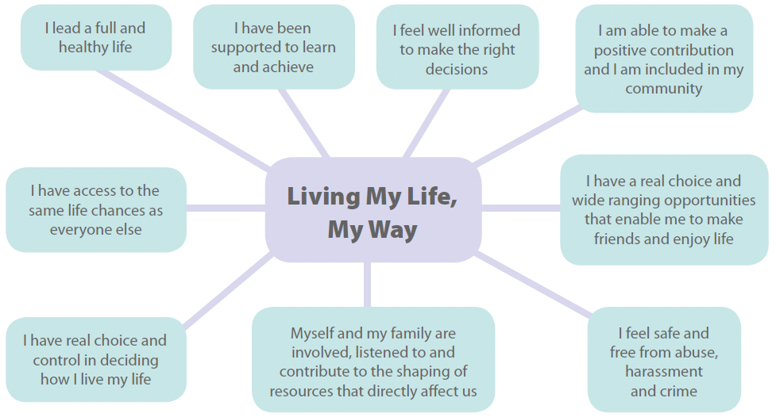

## How do we keep it person centred? How do we ensure we don’t lose sight of our key objectives?

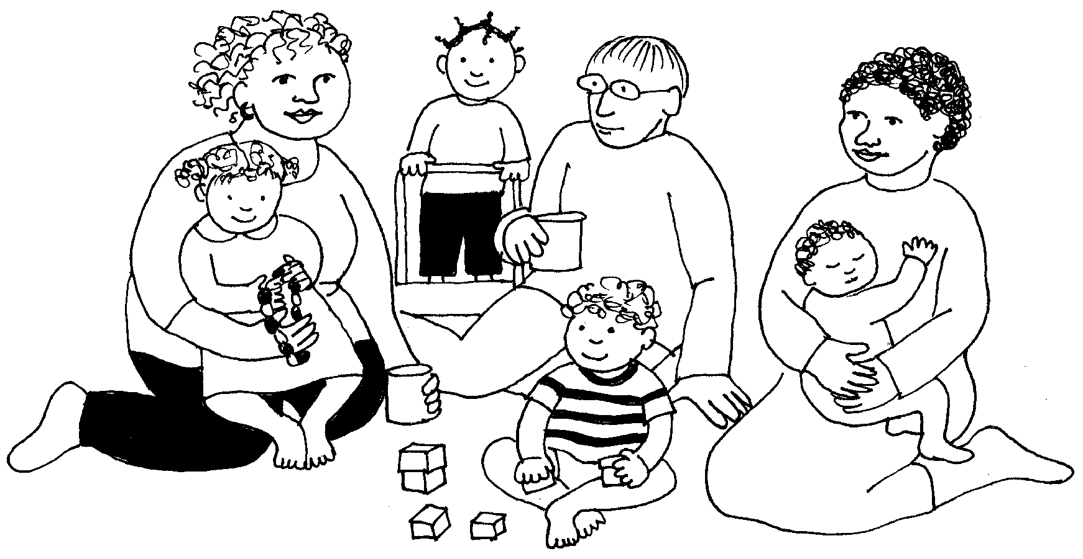

### We must keep asking ourselves the question:

### *‘What will it mean for Jo Bloggs and her family?’*

# The Front Door

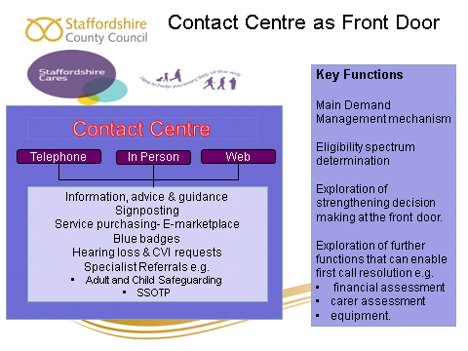

It is proposed that:

* The Contact Centre will be the front door for all SEND enquiries and all new referrals into IF
* IF and SEND will share a front door process within the contact centre
* The route for child safeguarding referrals will still be via the Families First First Response contact centre
* There were very few adult referrals into IF last year via the contact centre
* Evidence from elsewhere (e.g. Nottinghamshire) shows that a well resourced and robust contact centre can be effective in managing the demand for more specialist support from IF by providing early support without the need for IF involvement.

We will need to work with the contact centre to:

* Properly resource the contact centre with experienced staff, including qualified workers
* Develop new referral protocols for the Contact Centre to ensure thresholds are appropriately applied
* Work with Families First to ensure the current interfaces continue to be effective and deliver the best outcomes for young people

# The Key Worker Model

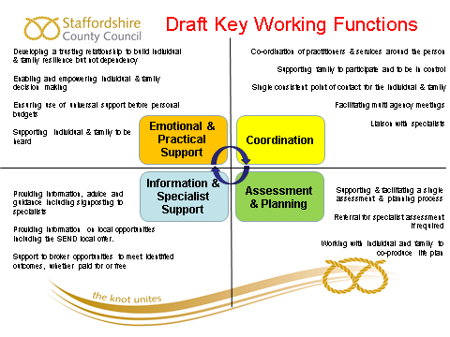

The Key Worker model is THE key concept at the heart of the Independent Futures model. In creating the IF concept, customer insight told us that:

* Support is too fragmented
* We keep having to repeat ourselves to lots of different professionals
* We lose track of who is doing what or who is responsible form what
* Parents and families often delay asking for help as they are worried that they could be judged as being inadequate parents because they are struggling to support the additional needs of their disabled child

The Key Worker model will address these issues by ensuring that Key Workers:

* Deliver continuity of support through one person who knows people well and is trusted by them
* Request specialist assessments for complex cases but stay involved. This will model will apply for both internal (Social Workers or OTs) and external (Health, Housing, Education) specialist assessments
* Know who is doing what by when, keeping people up to date and informed
* Are approachable and non-judgemental so opening up routes to ‘early help’ so people don’t wait for a crisis before asking for support[1].

It is proposed that:

* The model agreed will be for IF and SEND work
* Key Workers will carry out the brokerage function
* We adapt the above model to ensure that it fully captures all core social care functions such as resource allocation, brokerage and monitoring.

# Tools

**‘The best assessment tool is a blank piece of paper and a real conversation between equals’**

There is much to be said for the sentiment expressed above. IF SMT are of the strong opinion that in order to deliver a person centred, customer focused experience, we must focus on supporting staff to change how they interact with customers, rather than focusing on developing new tools.

New behaviours will make more difference to the way we are experienced by our customers than new tools. This must include delivering a customer led, ‘whole life’ assessment informed by the outcomes people want to achieve, that moves away from a narrow focus on paid for services.

# Key Principle

It is proposed that Independent Futures will use existing tools where at all possible, since these tools:

* are familiar to other professionals, disabled people and their families
* are embedded in existing data systems (Care Director, Capita etc)
* will continue to form a ‘best fit’ with external partners as other systems and developments come on line

Where there is no ‘exact fit’ between the tool and how IF wishes to use it, IF will work with staff to develop guidance to show how to capture or reflect IF requirements such as:

* Using the CAF to evidence eligibility and personal budget determination

### Education Health and Care Plans

The Children and Families Act 2014 and the associated SEND code of practice require all councils to introduce integrated support planning by September 2014.

IF and SEND will use the Darlington My Life Plan as the basis for the Education Health and Care Plan (EHCP) or Support Plan for both adults and children. This plan was developed as part of the national SEND pathfinder work and was chosen by a range of stakeholders including staff, partners, customers and carers as being the preferred model.

As this plan was developed from a SEND project, we will be working with IF practitioners and customers to ensure that the plan is IF friendly, including the need to show clear personal budgets.

The Common Assessment Framework (CAF) will continue to be the main IF assessment tool for Children & Young People.

FACE and BICA will continue to be the main adult tools.

We will work with the IF champions group to consider how best to use these tool and what guidance staff will need.

# Pathways and Thresholds

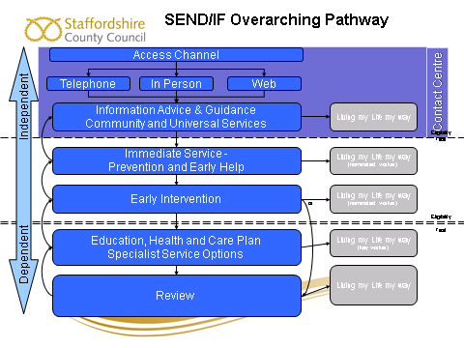

Independent Futures will continue to work within existing eligibility frameworks for both adults and Children.

It is proposed that

* Independent Futures will be embed into the SEND pathway
* All other front line roles in SEND and Independent Futures would convert to Key Workers
* Front line managers should be qualified Social Workers to:
  + enable ratification of thresholds and decision making
  + ensure referrals to specialists are made when needed
  + risks are identified and managed appropriately.

# Issues

In order to ensure every one is able to benefit from the Key Worker model, we need to develop a rationale that allows Key Workers to complete CAF with children and young people so the initial IF contact but does not breach the legal requirement that a Children in Need assessment is led by a qualified worker.

### Outline solution

* A child with impairments need not automatically be considered to be a disabled child, and therefore a child in need, in all circumstances.
* A CAF can be used to consider both Early Help (as per Children Act 2004) and the needs to the parents/carers (as per Carers and Disabled Children Act) in order to be able to quickly and easily offer a low to moderate amount of support to the child and family.
* Use legal powers under CSDPA and Carers legislation
* Work with Families First and SSCB to agree the model
* Discuss possible ‘flexibilities’ with DfE.

# Staffing Implications:

### Design Principles

We have no firm proposals for the Management and staffing structure as yet. We have ideas and during the design phase we need to develop these, through a process of co-production, into a proposal for an organisational structure that is built around the concept of the seamless all age service centred on the Key Worker model.

Key Workers will need access to supportive and responsive management that can quickly ratify decision making and the application of thresholds or eligibility criteria.

Social Workers and Occupational Therapists, acting as specialist assessors and based in locality teams, will need to be available to offer advice and support to key workers, contributing a full specialist assessment for more complex cases. They will also need access to professional support if their manager is from a different professional background.

Locality Managers will be managing a variety of staff from a variety of backgrounds and professions, so will need access to appropriate professional support and advice.

### Outline of a proposed model

The proposed model envisages:

* Double District Teams of key work & professional staff, covering adult & children’s work.
* That Social Workers can continue to be able to specialise in either adults or children’s work, recognising the legal complexities of both adults and children’s work.
* The creation of three Lead Professional posts (Adult Social Work, Children’s Social Work and Occupational Therapy) who will monitor quality via case work audits etc. and provide advice and guidance to staff and managers.
* Locality Managers and qualified workers will be able to seek support from Lead Professionals in complex cases.
* The proposed structure will push decision making back to the front line and offer more support to front line managers via lower spans of control.
* Budgets would be held within the key work structure.

We will work with staff and other stakeholder to co-produce an effective staffing structure within current financial constraints.

### Issues:

* How do we ensure SEND & IF are experienced as a single seamless pathway.
* Structure needs to be affordable.
* The model needs to be able to facilitate access to or contributions from other external specialist assessments.

# Cultural Change and Organisational Development

The main change that is required to transform both IF and SEND is to change the culture as experienced by our customers from bureaucratic to person centred.

|  |  |
| --- | --- |
| Bureaucratic | Person Centred |
| ‘Us and them’ | We |
| Expert | Collaborative |
| Service user/client | Customer |
| Paternalistic | Partnership |
| Professional power | Empowering |
| Take it or leave it | Choice |
| Receive | Control |
| Decide | Agree |
| Passive | Active |

Cultural transformation is not about acquiring new skills or knowledge but about changing staff behaviours.

Cultural issues are similar for both IF and SEND and the new working model for both will require the same cultural transformation. We need to re-establish the vision and values behind the All Age Disability Strategy and get them ‘front of mind’ for all the work force for both IF and SEND.

***Cultural Indicators***

Language is an important cultural indicator. We need to move from using the term ‘client/service user’ to talking about our ‘customers’.

Possible learning activity: What does our language say about us as individuals and as an organisation

Staff always answering their own phones is another key indicator to a collaborative culture. It shows a willingness to engage in dialogue, not hide behind systems or create barriers.

First Impressions Count. Carers say they can tell the attitude of a worker by the way they approach the front door.

Possible Learning Activity: How do we make our body language say ‘You can trust me’ ‘I am listening’ ‘I respect your views’.

### Managers as Leaders

In order to free up managers to both lead the transformational change and provide more support to front line staff, we are proposing 2 new ways of working

1. A refocusing of the role of admin teams to explicitly support managers with data and management information tasks.
2. An expectation that front line staff should be self supporting as key principle, reducing reliance on admin. For example staff will be expected to

* answer their own phones or use voicemail to take messages
* complete their own data entry tasks rather than passing completed forms to admin

# Stakeholder Engagement

**As stated above, phase 2 of the transformation project for IF is a design phase.**

**It is our explicit intention that the transformational changes are designed in partnership with all relevant stakeholders including**

* **Adults with Learning Disabilities**
* **Disabled Children**
* **Families and Carers**
* **Independent Futures Staff**
* **Partner Organisations including CCGs**
* **SLT**
* **Members**

**Throughout phase 2 we will be creating opportunities for all stakeholders to shape the design of the new operating model and to ensure that the new model has the best possible chance of creating the seamless all age service that can deliver both improved customer experience and improved outcomes for disabled people and their families** while offering value for money to the Council**.**

**Engagement will continue thought phases 3 and 4 to ensure that stakeholders can hold us to account and that we are delivering the transformational changes we have promised.**

**The programme of engagement with staff, customers and stakeholders, which informed the original vision for Independent Futures, will be consolidated during the design phase. We will continue to use existing channels to build on this engagement throughout the rest of the programme of transformation.**

**We will work with the corporate engagement and communications teams to develop a communications and engagement plan which will be shared widely and updated as the project progresses.**

## ****Have your Say.****

**If you have any comments about this outline plan, we would love to hear from you.**

**Please send them to** [independent.futures2@staffordshire.gov.uk](mailto:independent.futures2@staffordshire.gov.uk)

1. See [‘Ties that Bind’](http://www.demos.co.uk/publications/tiesthatbind) Demos 2014